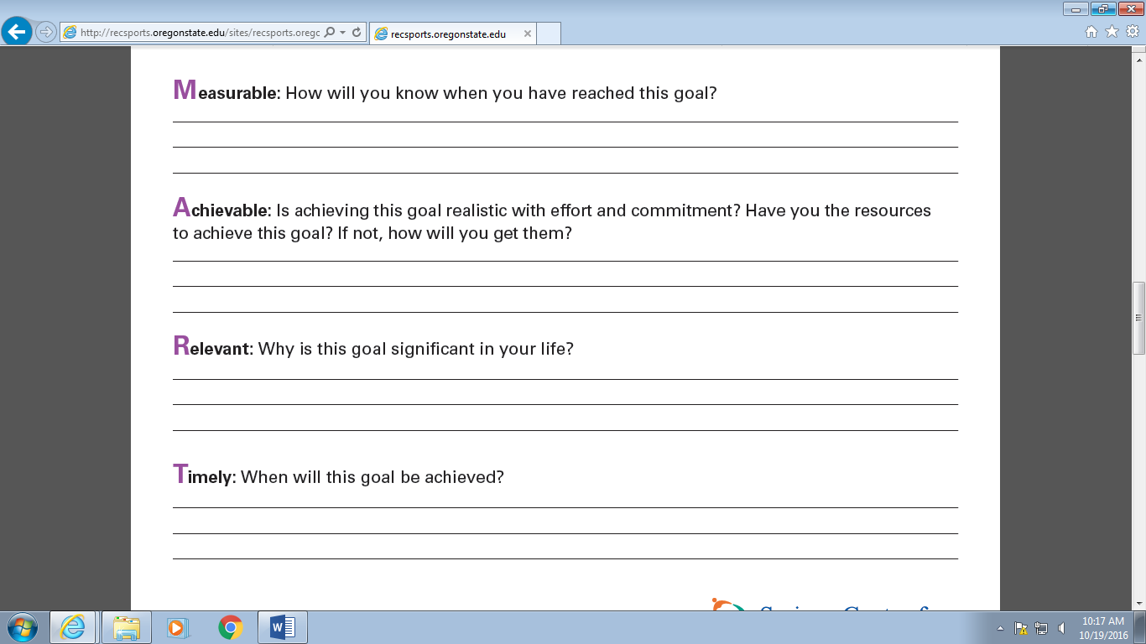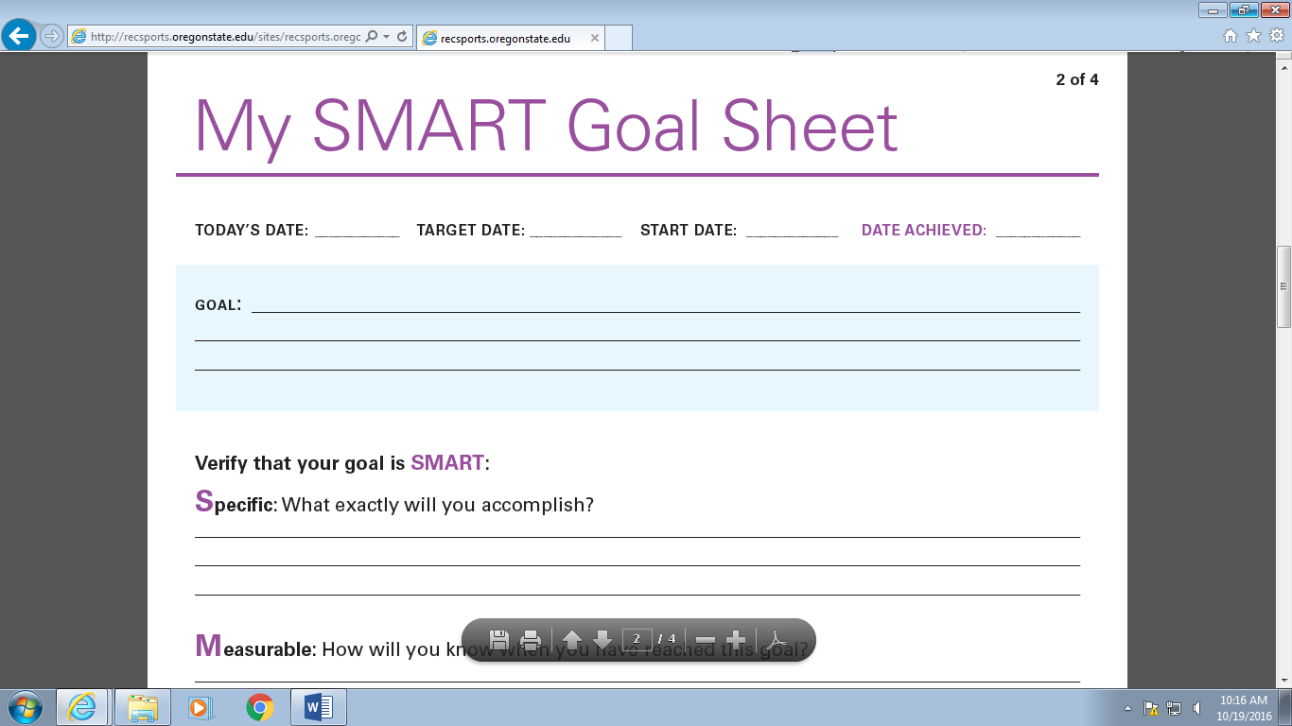

**What is one barrier that may make your goal difficult? How can you overcome it?**

**________________________________________________________________________________________**

**________________________________________________________________________________________**

**________________________________________________________________________________________**